**Name:________________________________________ Year 9 Chemistry**

**Atoms and the Periodic Table Mini Test**

|  |  |
| --- | --- |
| Question | Answer |
| 1 | A B C D |
| 2 | A B C D |
| 3 | A B C D |
| 4 | A B C D |
| 5 | A B C D |
| 6 | A B C D |
| 7 | A B C D |
| 8 | A B C D |
| 9 | A B C D |
| 10 | A B C D |

**Part A Multiple Choice Section**

*Please use the table on the right of this page for your answers*

1. The atomic number of an element is equivalent to the number of

A protons

B neutrons

C electrons

D charges

2. Which of the following has a positive charge?

A protons

B neutrons

C electrons

D none of the above

3. Which of the following is found in a different area of the atom than the others

A protons

B neutrons

C electrons

D none of the above

***The next 4 questions refer the following periodic table***

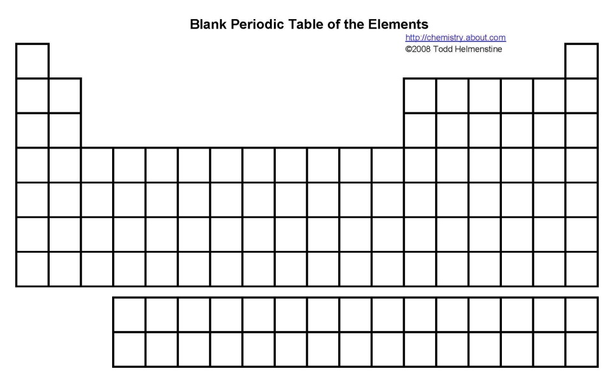

**C**

**D**

**E**

**A**

**B**

4. Which area on the periodic table would contain the most reactive elements?

A A

B B

C C

D D

5. In Which area are the metals found?

A A

B B

C D

D E

6. Which area contains only gases?

A None of the areas

B B

C D

D E

7. In which area would you find the elements most likely to lose (give away)their valence electrons?

A A

B B

C D

D E

8. An ion is

A an atom with more neutrons than electrons

B an atom with the same number of protons and electrons

C an atom with different numbers of protons and electrons

D an atom with valence electrons

9. Organic compounds are

A those with a carbon backbone

B those found in living things

C in group 5 of the periodic table

D elements joined together by carbon bonds

10. The best description for a molecule is

A elements of the same type chemically joined together

B more than one atom chemically joined

C elements of different types chemically bonded

D a compound

**Part B Vocabulary**

1. ___________________ The number of neutrons plus the number of protons.

2. ___________________ Everything that has mass and takes up space.

3. ___________________ The area of an atom where protons and neutrons are found.

4. ___________________ The rows on a periodic table

5. ___________________ Metals with complex properties arising from the arrangement of their

electrons. They have variable valence.

6. ___________________ A charged atom.

7. ___________________ A group of elements with a full valence shell.

8. ___________________ Two or more different chemical elements bonded together

9. ___________________ A group of very reactive non metals

10. ___________________ The correct term to describe columns on a periodic table